BREAST CANCER

IN

WEB ENGINERRING

BY

|  |  |  |
| --- | --- | --- |
|  | **NAME** | ID |
|  |  |  |
|  |  |  |
|  |  |  |

TO

DR.NAME HERE

Table of content:

|  |  |  |
| --- | --- | --- |
|  | Title | Page |
| 1 | Introduction | 4 |
| 1.1 | Overview of the project | 4 |
| 1.2 | Objective of the project | 5 |
| 2 | System analysis | 6 |
| 3 | Hardware & Software Requirements | 8 |
| 3.1 | Hardware requirements | 8 |
| 3.2 | Software Requirements | 8 |
| 4 | Analysis and Design | 9 |
| 4.1 | DFD | 9 |
| 4.2 | USE-CASE Diagrams | 10 |
| 4.3 | Activity Diagrams | 11 |
| 5 | Design of | 12 |
| 5.1 | Login page | 12 |
| 6 | Implementation | 14 |
| 6.1 | Modul Details | 14 |
| 6.2 | Sample code for all modules | 15 |

Work Breakdown:

|  |  |  |
| --- | --- | --- |
|  | Task | Roles |
| 1 | Introduction | All members |
| 1.1 | Overview of the project | All members |
| 1.2 | Objective of the project | All members |
| 2 | System analysis | All members |
| 3 | Hardware & Software Requirements | All members |
| 3.1 | Hardware requirements | All members |
| 3.2 | Software Requirements | All members |
| 4 | Analysis and Design | All members |
| 4.1 | DFD | All members |
| 4.2 | USE-CASE Diagrams | All members |
| 4.3 | Activity Diagrams | All members |
| 5 | Design of | All members |
| 5.1 | Login page | All members |
| 6 | Implementation | All members |
| 6.1 | Modul Details | All members |
| 6.2 | Sample code for all modules | All members |

Time table:

|  |  |  |
| --- | --- | --- |
|  | Title | Duration |
| 1 | Introduction | 1 day |
| 1.1 | Overview of the project | 5 hours |
| 1.2 | Objective of the project | 5 hours |
| 2 | System analysis | 2 days |
| 3 | Hardware & Software Requirements | 2 days |
| 3.1 | Hardware requirements | 1 day |
| 3.2 | Software Requirements | 1 day |
| 4 | Analysis and Design | 4 days |
| 4.1 | DFD | 2 days |
| 4.2 | USE-CASE Diagrams | 1 day |
| 4.3 | Activity Diagrams | 1 day |
| 5 | Design of | 3 days |
| 5.1 | Login page | 3 days |
| 6 | Implementation | 4 days |
| 6.1 | Modul Details | 2 days |
| 6.2 | Sample code for all modules | 2 days |

Gantt chart:

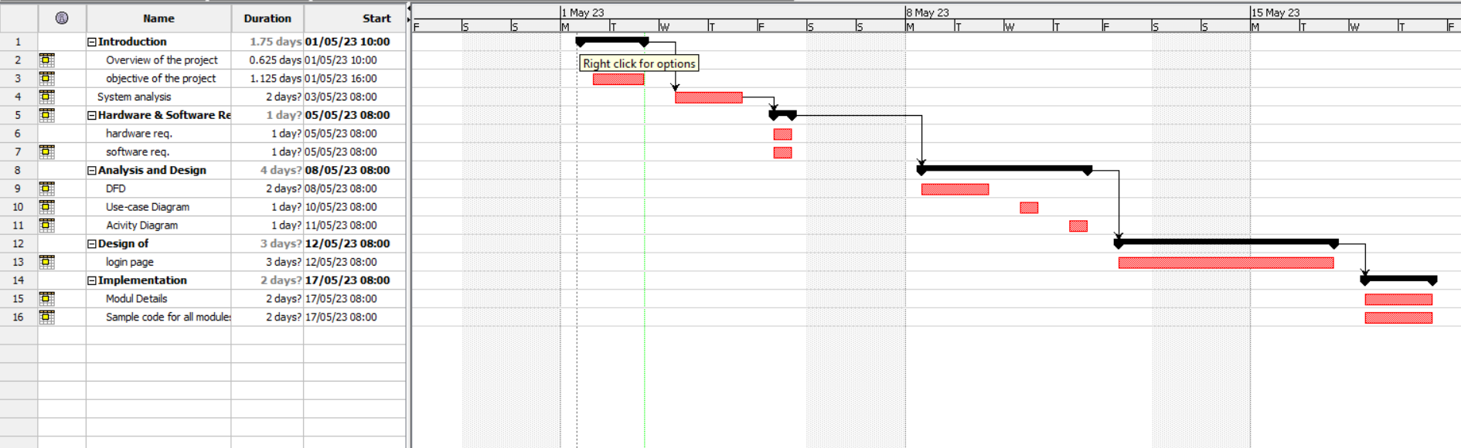

1. **Introduction:**

With the increasing number of persons diagnosed with breast cancer, it is critical to educate all people, whether female or male, about the necessity of periodic screening, as well as identifying signs and performing the initial check at home.

It is also critical that intense free courses or events relevant to this issue be held in order to reach the greatest amount of people with this information.

Because we live in a fast-paced world, the best way to spread awareness, steps, and tasks is through the quickest way to deliver information, which is through websites.

As a result, we decided to build a website that discusses breast cancer, the number of injuries, the significance of inspection, and home examination methods.

**1.1 Overview of the project:**

The project will cover a variety of issues, but they will all revolve around one central theme breast cancer.

The user will be able to browse numerous sections, including:

The home page, which will serve as a portal to the remaining sections, will tell the tale of prior breast cancer, including its origins, history, and patient count.

a page linked to the manner of examination in clinics or even the initial examination at home.

There is also a page that lists the most significant points for testing in our region.

So that all users can search and explore, as well as feed their thoughts with material that will help them learn more about this disease.

**1.2 Objective of the project:**

**Aim:**

* To disseminate more information on mindful cancer so that everyone is better aware of breast cancer and its complications.

**Objective:**

* Everyone should be aware of the history of breast cancer, including its origins and progression.
* Access to accurate and verified information is made simple.
* knowledge of examination methodologies and information on the significance of periodic examination.
* Raising cultural consciousness among all members of society.

1. **System analysis:**

There are many methodologies that are used in systems analysis and design, and it is chosen based on its steps that help developers or programmers understand, create and test their projects. In our case, we will use the waterfall approach along with informatics engineering.

Our reliance on the Waterfall approach in order to make the site is because of the clear steps it provides us. Therefore, we will have a clear plan in determining the requirements of our system, as well as developing it, testing it, and finally modifying it. Of course, this approach is difficult to modify and expensive in the event of starting implementation, but it was chosen because we have already limited the design ours.

As for information engineering, we will use it to define relationships within the system as well as to determine the way that connects us to the rest of the site and the sources from which we will derive our information.

* 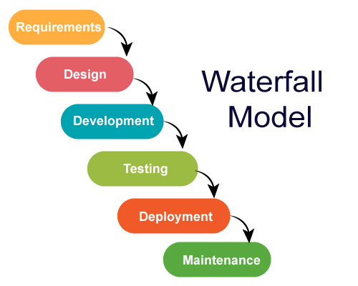Waterfall methodology:
* System scenario:

|  |  |  |
| --- | --- | --- |
|  | Primary actors | Scenario |
| 1 | User | Register, login, logout.  View pages.  Search.  Browse. |
| 2 | Administrator | Login, logout.  Manage the articles and website.  Add new articles or new pages. |

1. **Hardware and software Requirements:**

In order to implement our project, we will need a number of programs and applications to work on. We will mention the most prominent of them, but some of them may change due to some circumstances that may relate to the availability of the required tools and others.

**3.1 Hardware requirements:**

|  |  |  |
| --- | --- | --- |
|  | Hardware: | Features: |
| 1 | **CPU** | **Intel Core 5** |
| 2 | **RAM** | **8.0 GB** |
| 3 | **OS** | **Windows 10** |
| 4 | **SYSTEM** | **64-bit Operating System** |

**3.2 Software requirements:**

* Visual code: to implement the HTML5, CSS and JS codes.
* Creately: for creatin the diagrams.
* Microsoft office Word: to create the main document.
* Mozilla Firefox: to explore and run the codes.

1. **Analysis and Design:**

**4.1 DFD:**

A data flow diagram (DFD) is a graphical or visual representation using a standardized set of symbols and notations to describe a business's operations through data movement

Because our site is generally based on browsing and does not have many procedures except for the login stage, we decided that the form should be for login and another for the admin adding new article.

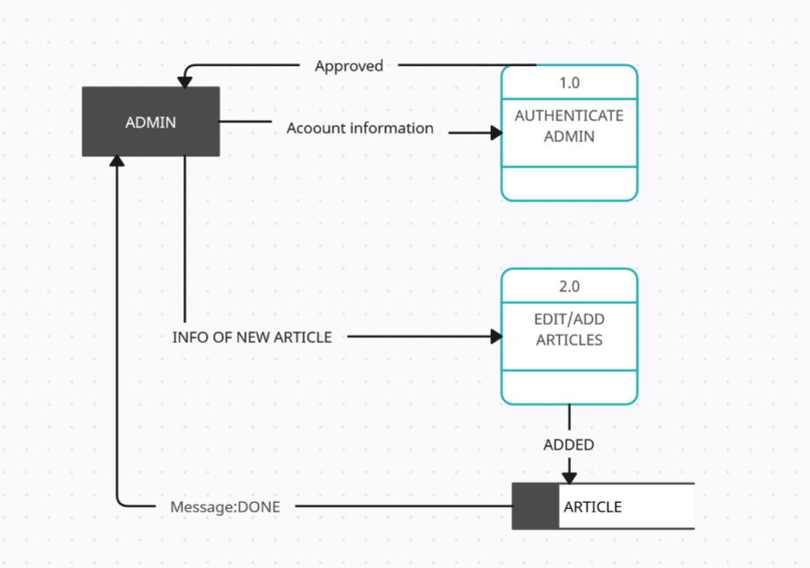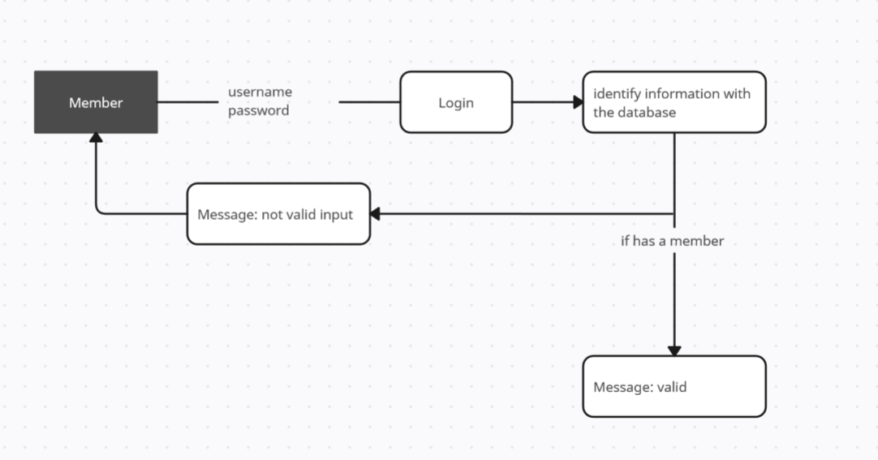

Figure 2- Insert New Article DFD

Figure 1- Login DFD

**4.2 Use-Case Diagram:**

In the Unified Modelling Language (UML), a use case diagram can summarize the details of your system's users (also known as actors) and their interactions with the system.

* User can just browse the website but use have to login if wants to write an article or left a comment (to add first article user have to left comments in other articles)
* Authenticator can browse the website check the login page for users and check the validate comments.
* Admin have to login to the website if wants to add articles or left replies also can browse the website.

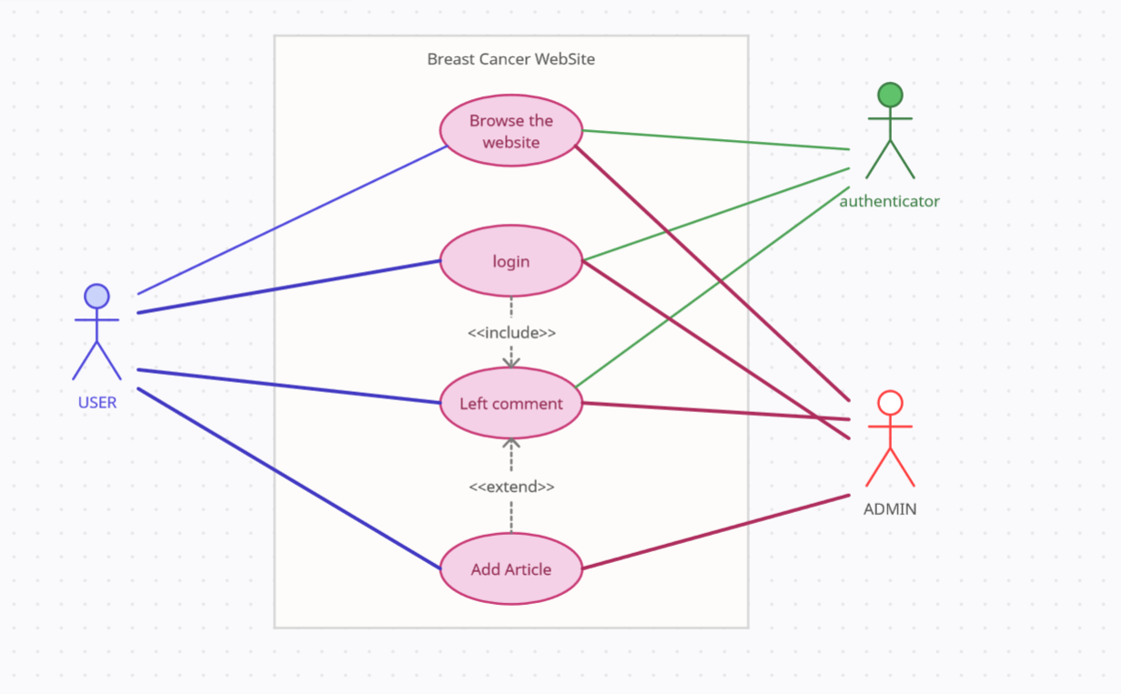

Figure 3- Use-Case Diagram

**4.3 Activity Diagram:**

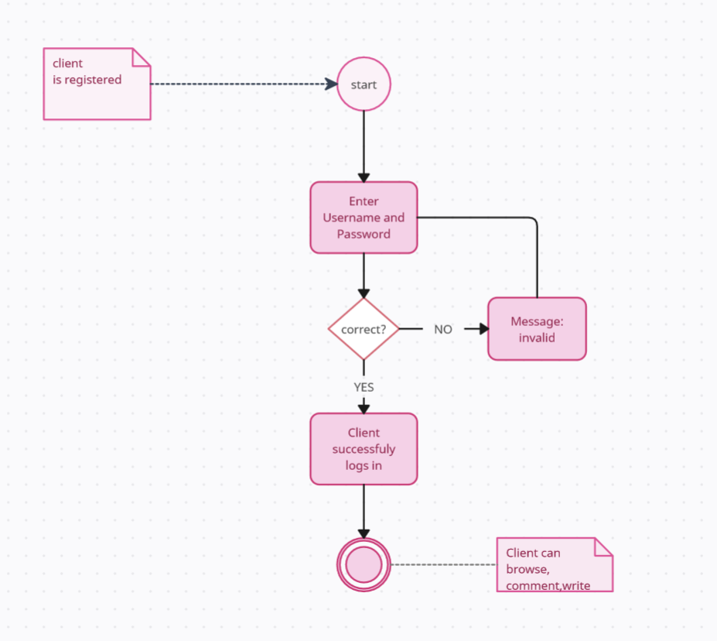The Unified Modelling Language includes several subsets of diagrams, including structure diagrams, interaction diagrams, and behaviour diagrams. Activity diagrams, along with use case and state machine diagrams, are considered behaviour diagrams because they describe what must happen in the system being modelled.

Figure 4- Activity Diagram for Login Page

* 1. **Design of:**

**5.1 LOGIN PAGE:**

Since the site was established and designed with the aim of benefiting and aiding all segments of society, the login interface was designed to be as simple and easy as possible so that all users can deal with it and register on the site with ease and smoothness.

Of course, the typography, coordination, and colors of the user interface were designed to be basically compatible with the idea of the site.

**Fill out the form for a new user page:**

* First name and last name are mandatory.
* A valid email address is mandatory.
* Password is required
* Optionally requires a mobile number.
* Optional date of birth required.
* It requires approval of the site's policies on a mandatory basis.
* Register button

**Fill out the form for a user page:**

* Username/email is required.
* Password is required.
* enter button

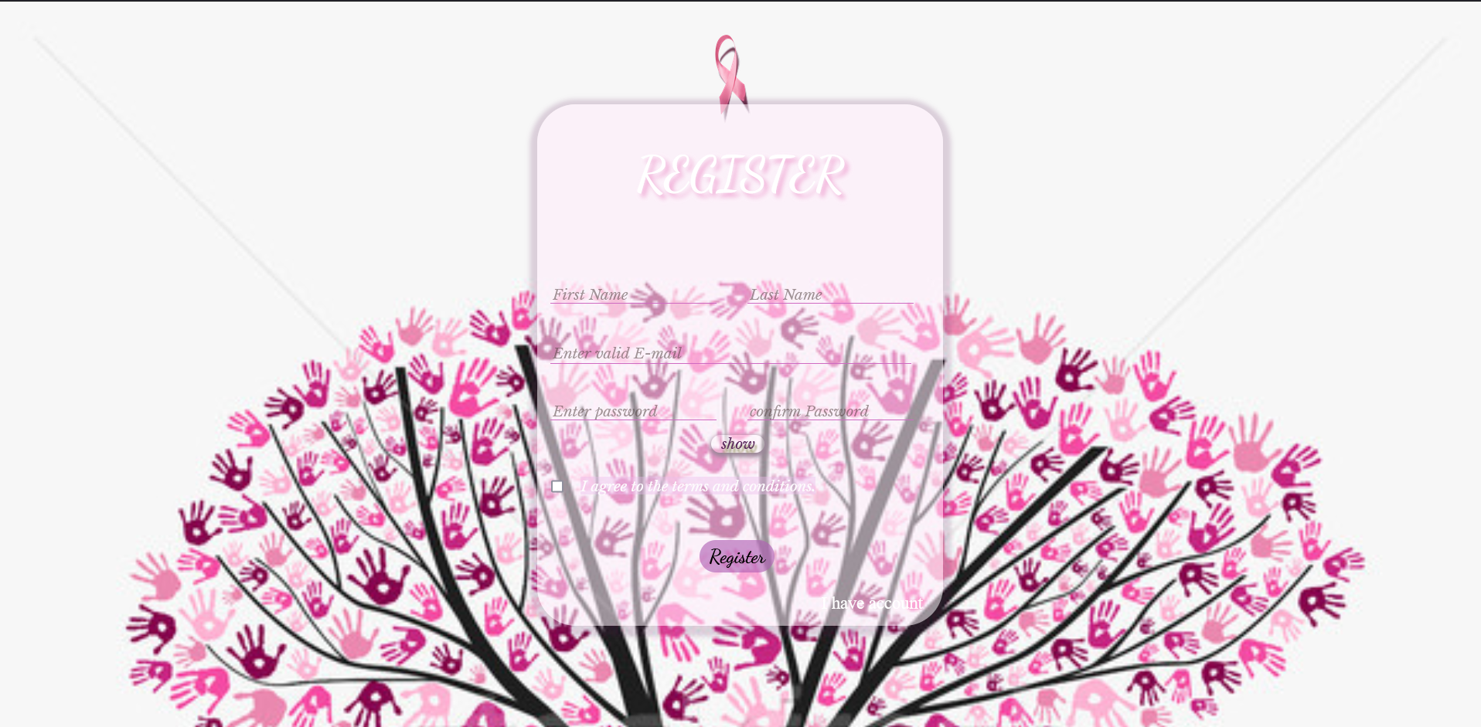

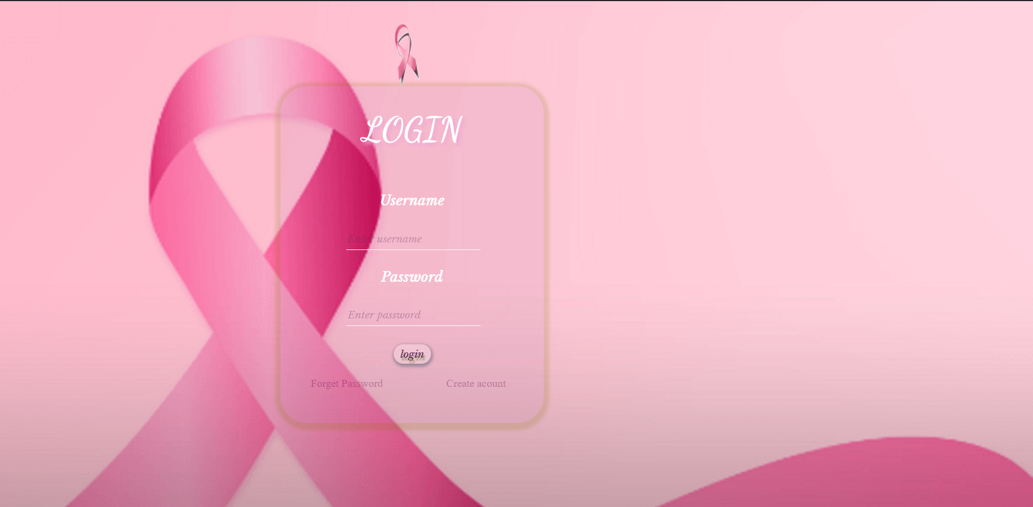

1. **Implementation:**

This system will not be introduced until it has been thoroughly tested.

And checks are performed to ensure that the system operates in accordance with the specifications; if an error is discovered, it must be repaired immediately, and the test must be restarted from the beginning.

The users must then be instructed on how to operate the system, which is another complex and time-consuming task.

During the implementation phase, the following factors are taken into account:

* **Hardware compatibility:** determines whether the system meets the minimum HW requirements for the software to run on the client system.
* **Browser compatibility:** whether the client system's browser supports JavaScript and PHP.

**6.1** **THE MODULES DETAILS:**

* Admin and users:

In these modules, the admin will add several articles to be read, browsed, or even shared and evaluated by users who will get this feature from adding useful scientific articles on the same topic or adding their experiences and others after registering on the site and then confirming their first post with a comment.

* Authenticator module

In this module, the person responsible for authentication, security, and control will authenticate the users' entry safely and smoothly. He will also monitor the content within the site and the articles that are published or commented on from any bad or errors.

* Articles and other content:

Here it will be managed mainly by the site administrator. He will publish official articles on topics related to the site only. He will also be responsible for the responses and comments of any user.

Secondly, some users will also have the authority to publish articles, but after they are confirmed, documented, and free of any false information.

1. **Sample codes:**

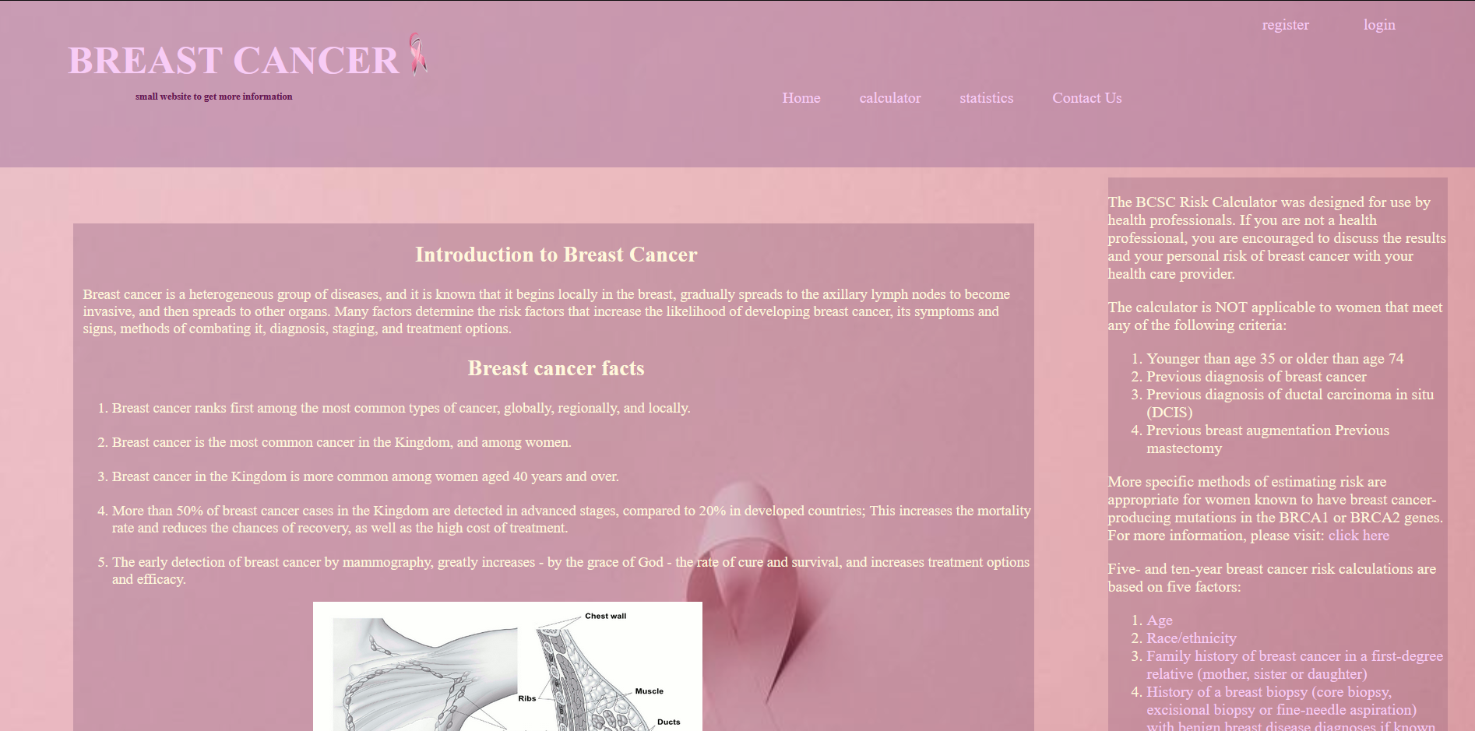

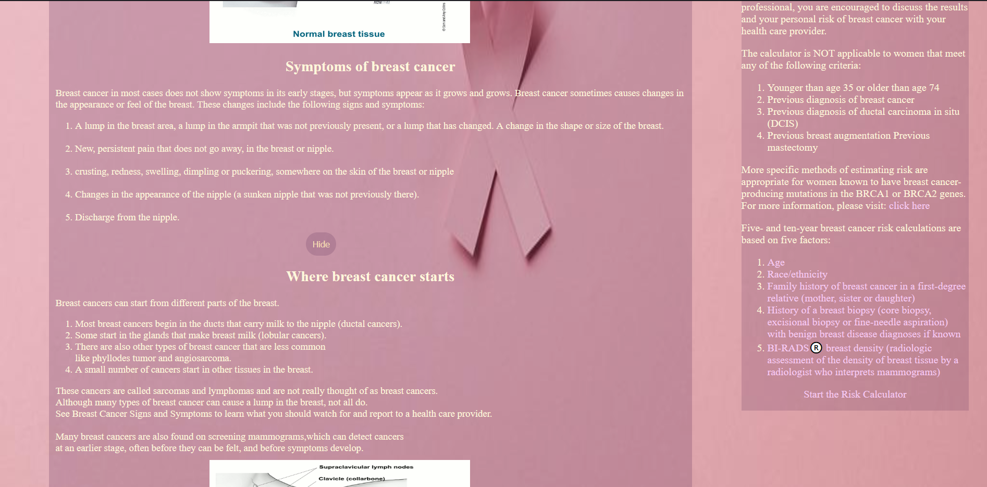

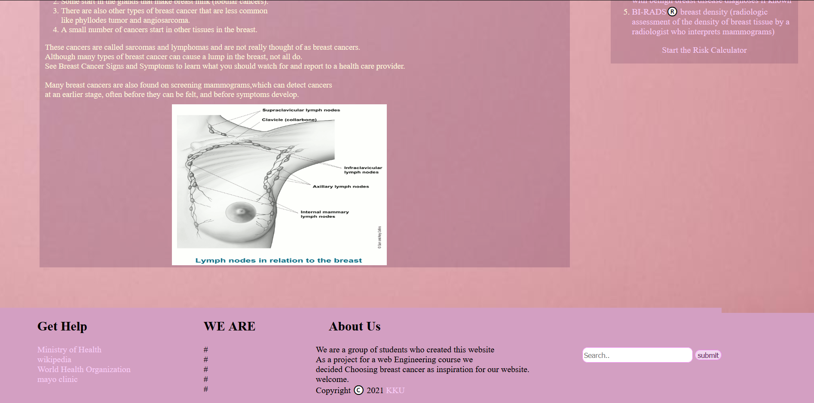





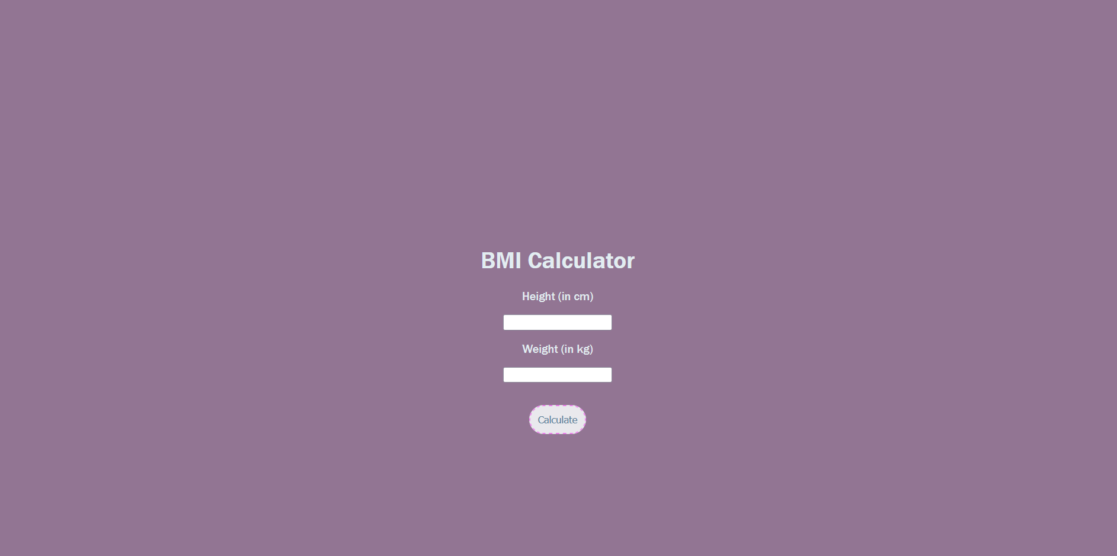

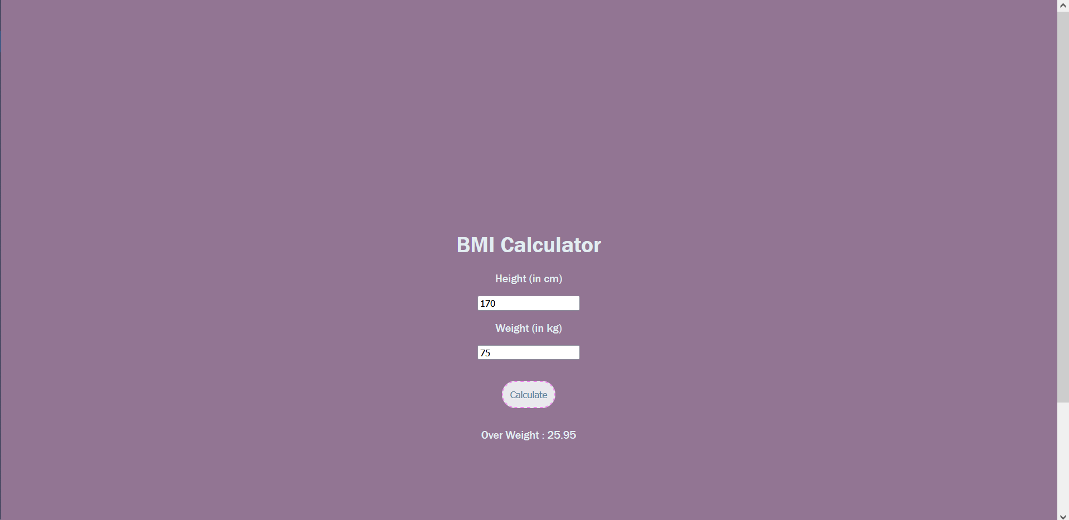

Home Page html js and css:

<!DOCTYPE html>

<html lang="en">

<head>

    <meta charset="UTF-8">

    <meta http-equiv="X-UA-Compatible" content="IE=edge">

    <meta name="viewport" content="width=device-width, initial-scale=1.0">

    <link rel="icon" href="img/icon.png">

    <link rel="stylesheet" href="home.css">

    <title>home</title>

</head>

<body class="homeBody">

    <header>

        <div id="homeTopDiv">

            <ul id="homeTopDiv">

                <li class="homeLogLi">

                    <a href="login.html" target="_blanck"> login </a>

                </li>

                <li class="homeLogLi">

                    <a href="register.html" target="_blanck"> register</a>

                </li>

            </ul>

        </div>

        <div id="homeFirstDiv">

            <div id="homeSiteMenu">

                <ul class="homeUl">

                    <li class="homeLi"><a href="contact.html" target="_blanck">Contact Us</a></li>

                    <li class="homeLi"><a href="statistics.html" target="_blanck">statistics</a></li>

                    <li class="homeLi"><a href="info.html" target="_blanck">calculator</a></li>

                    <li class="homeLi"><a href="home1.html" class="current">Home</a></li>

                </ul>

                <img src="img/icon.png" alt="logo" style="height: 50px; width: 50px; margin: 0 -65%;">

            </div>

            <div id="homeSiteTitle">

                <h1 id="homeFirstH1"><a href="home1.html">BREAST

              CANCER<br><h2 id="homeFirstH2" style="color: rgb(102, 25, 83); padding: 0 70px;">small website to get more information</h2></a></h1>

            </div>

        </div>

    </header>

    <div class="homeBodyDiv">

        <article class="homeArticle">

            <h1 style="text-align: center;">​​ Introduction to Breast Cancer </h1>

            <p style="margin: 0 0 0 10px;">

                Breast cancer is a heterogeneous group of diseases, and it is known that it begins locally in the breast, gradually spreads to the axillary lymph nodes to become invasive, and then spreads to other organs. Many factors determine the risk factors that

                increase the likelihood of developing breast cancer, its symptoms and signs, methods of combating it, diagnosis, staging, and treatment options.

            </p>

            <h1 style="text-align: center;">​​ Breast cancer facts </h1>

            <p style="margin: 0 0 0 10px;">

                <ol>

                    <li>Breast cancer ranks first among the most common types of cancer, globally, regionally, and locally.</li>

                    <br>

                    <li> Breast cancer is the most common cancer in the Kingdom, and among women.</li>

                    <br>

                    <li>Breast cancer in the Kingdom is more common among women aged 40 years and over.</li>

                    <br>

                    <li> More than 50% of breast cancer cases in the Kingdom are detected in advanced stages, compared to 20% in developed countries; This increases the mortality rate and reduces the chances of recovery, as well as the high cost of treatment.</li>

                    <br>

                    <li>The early detection of breast cancer by mammography, greatly increases - by the grace of God - the rate of cure and survival, and increases treatment options and efficacy. </li>

                </ol>

                <img src="img/nbt.gif" alt="start of Breast cancer" id="nbt">

            </p>

            <h1 style="text-align: center;">​​Symptoms of breast cancer </h1>

            <p style="margin: 0 0 0 10px;">

                <p style="margin: 0 0 0 10px;">Breast cancer in most cases does not show symptoms in its early stages, but symptoms appear as it grows and grows. Breast cancer sometimes causes changes in the appearance or feel of the breast. These changes include the following signs

                    and symptoms:

                </p>

                <ol>

                    <li>A lump in the breast area, a lump in the armpit that was not previously present, or a lump that has changed. A change in the shape or size of the breast.</li>

                    <br>

                    <li> New, persistent pain that does not go away, in the breast or nipple.</li>

                    <br>

                    <li>crusting, redness, swelling, dimpling or puckering, somewhere on the skin of the breast or nipple</li>

                    <br>

                    <li> Changes in the appearance of the nipple (a sunken nipple that was not previously there).</li>

                    <br>

                    <li>Discharge from the nipple. </li>

                </ol>

            </p>

            <button id="showHide" style="margin: 0 40%; padding: 1%; border-radius: 40px; border: none; background-color: rgba(73, 25, 75, 0.171); color: wheat;"> show more..</button>

            <div id="foo" style="display:none">

                <h1 style="text-align: center;">Where breast cancer starts</h1>

                <p style="margin: 0 0 0 10px;">

                    Breast cancers can start from different parts of the breast.</p>

                <ol>

                    <li>Most breast cancers begin in the ducts that carry milk to the nipple (ductal cancers).</li>

                    <li>Some start in the glands that make breast milk (lobular cancers).</li>

                    <li> There are also other types of breast cancer that are less common

                        <br> like phyllodes tumor and angiosarcoma.</li>

                    <li> A small number of cancers start in other tissues in the breast. </li>

                </ol>

                <p style="margin: 0 0 0 10px;">These cancers are called sarcomas and lymphomas and are not really thought of as breast cancers.</p>

                <p style="margin: 0 0 0 10px;">Although many types of breast cancer can cause a lump in the breast, not all do.

                    <br> See Breast Cancer Signs and Symptoms to learn what you should watch for and report to a health care provider.

                    <br>

                    <br> Many breast cancers are also found on screening mammograms,which can detect cancers <br> at an earlier stage, often before they can be felt, and before symptoms develop.

                </p>

                <img src="img/lnrb.gif" alt="" id="lnrb">

            </div>

            <script>

                document.getElementById("showHide").onclick = function() {

                    var theDiv = document.getElementById("foo");

                    if (theDiv.style.display == 'none') {

                        theDiv.style.display = 'block';

                        this.innerHTML = 'Hide';

                    } else {

                        theDiv.style.display = 'none';

                        this.innerHTML = 'Show';

                    }

                }

            </script>

        </article>

        <aside class="homeAside">

            <p>

                The BCSC Risk Calculator was designed for use by health professionals. If you are not a health professional, you are encouraged to discuss the results and your personal risk of breast cancer with your health care provider.</p>

            <p>The calculator is NOT applicable to women that meet any of the following criteria:</p>

            <p>

                <ol>

                    <li>

                        Younger than age 35 or older than age 74

                    </li>

                    <li>Previous diagnosis of breast cancer </li>

                    <li>Previous diagnosis of ductal carcinoma in situ (DCIS)</li>

                    <li> Previous breast augmentation Previous mastectomy</li>

                </ol>

            </p>

            <p>More specific methods of estimating risk are appropriate for women known to have breast cancer-producing mutations in the BRCA1 or BRCA2 genes. For more information, please visit:

                <a href="http://bcb.dfci.harvard.edu/bayesmendel/brcapro.php

                " target="_blanck"> click here</a>

            </p>

            <p>Five- and ten-year breast cancer risk calculations are based on five factors:</p>

            <p>

                <ol>

                    <li>

                        <a href="https://tools.bcsc-scc.org/BC5yearRisk/riskfactors.htm#age" target="_blanck"> Age</a>

                    </li>

                    <li>

                        <a href="https://tools.bcsc-scc.org/BC5yearRisk/riskfactors.htm#race" target="_blanck">Race/ethnicity</a>

                    </li>

                    <li>

                        <a href="https://tools.bcsc-scc.org/BC5yearRisk/riskfactors.htm#family" target="_blanck">Family history of breast cancer in a first-degree relative (mother, sister or daughter)</a>

                    </li>

                    <li>

                        <a href="https://tools.bcsc-scc.org/BC5yearRisk/riskfactors.htm#biopsy" target="_blanck">History of a breast biopsy (core biopsy, excisional biopsy or fine-needle aspiration) with benign breast disease diagnoses if known</a>

                    </li>

                    <li>

                        <a href="https://tools.bcsc-scc.org/BC5yearRisk/riskfactors.htm#density" target="_blanck">BI-RADS®️ breast density (radiologic assessment of the density of breast tissue by a radiologist who interprets mammograms)</a>

                    </li>

                </ol>

            </p>

            <p style="text-align: center;">

                <a href="https://tools.bcsc-scc.org/BC5yearRisk/calculator.htm" target="_blanck">Start the Risk Calculator</a>

            </p>

        </aside>

    </div>

    <footer id="homeFooter">

        <div class="homeFooterDiv">

            <div class="homeFooterDiv1">

                <h2 class="homeFooterH2"> Get Help</h2>

                <ul class="homeFooterUl">

                    <li class="homeFooterLi"><a href="https://www.moh.gov.sa/HealthAwareness/EducationalContent/wh/Breast-Cancer/Pages/default.aspx" target="_blanke" class="homeFooterLinks">Ministry of Health</a></li>

                    <li class="homeFooterLi"><a href="https://ar.wikipedia.org/wiki/سرطان_الثدي" target="_blanke" class="homeFooterLinks">wikipedia</a></li>

                    <li class="homeFooterLi"><a href="https://www.who.int/ar/news-room/fact-sheets/detail/breast-cancer" target="_blanke" class="homeFooterLinks"> World Health Organization</a></li>

                    <li class="homeFooterLi"><a href="https://www.mayoclinic.org/ar/diseases-conditions" target="_blanke" class="homeFooterLinks">mayo clinic</a></li>

                </ul>

            </div>

            <div class="homeFooterDiv1">

                <h2 class="homeFooterH2"> WE ARE</h2>

                <ul class="homeFooterUl">

                    <li class="homeFooterLi">#</li>

                    <li class="homeFooterLi">#</li>

                    <li class="homeFooterLi">#</li>

                    <li class="homeFooterLi">#</li>

                    <li class="homeFooterLi">#</li>

                </ul>

            </div>

            <div class="homeFooterDiv1">

                <h2 class="homeFooterH2">About Us</h2>

                <p class="homeFooterP">We are a group of students who created this website <br> As a project for a web Engineering  course we <br> decided Choosing breast cancer as inspiration for our website. <br> welcome. <br> Copyright ©️ 2021 <a href="https://www.kku.edu.sa/"

                        target="_blanke">KKU</a></p>

            </div>

            <div class="homeFooterDiv2">

                <form action="/action_page.php">

                    <input type="text" placeholder="Search.." name="search" id="homeSearchBar">

                    <button type="submit" id="homeSearchButton"><i ></i>submit</button>

                </form>

            </div>

        </div>

    </footer>

</body>

</html>

.homeBody {

    margin: 0;

    padding: 0;

    background-color: rgb(211, 159, 194);

    background-image: url(img/back1.jpg);

    background-size: 100% 92%;

    background-repeat: no-repeat;

}

#homeTopDiv,

.homeLogLi {

    display: inline;

    list-style: none;

    padding: 20px;

    margin: -15px 8px;

    float: right;

    font-family: 'Libre Baskerville', serif;

}

#homeFirstDiv {

    padding: 0;

    margin: 0;

}

#homeSiteTitle {

    font-family: 'Sorts Mill Goudy', serif;

    font-weight: 50px;

    text-align: left;

    font-size: 20px;

    padding: 10px;

    padding-bottom: 2em;

    background-color: rgba(146, 97, 148, 0.39);

}

#homeFirstH2 {

    font-family: 'Libre Baskerville', serif;

    font-size: 10px;

    text-align: left;

}

#homeFirstH1 {

    padding-left: 1.5em;

}

#homeSiteMenu,

.homeUl,

.homeLi {

    list-style: none;

    display: inline;

    margin: 10px -50px;

    padding: 20px 70px;

    float: right;

    font-family: 'Libre Baskerville', serif;

}

a {

    text-decoration: none;

    color: rgb(248, 204, 246);

}

a:hover,

a:active {

    color: rgb(17, 5, 17);

}

.homeSection {

    margin: 0;

    padding: 0;

}

#nbt {

    height: 300px;

    width: 400px;

    margin: 0 25%;

}

#lnrb {

    height: 300px;

    width: 400px;

    margin: 1% 25% 0% 25%;

}

.homeAside {

    margin: -75% 2% 5% 75%;

    float: left;

    background-color: rgba(73, 25, 75, 0.171);

    color: cornsilk;

    font-family: 'Libre Baskerville', serif;

}

.homeArticle {

    margin: 2% 30% 5% 5%;

    float: right;

    background-color: rgba(73, 25, 75, 0.205);

    color: cornsilk;

    font-family: 'Libre Baskerville', serif;

    font-size: 15px;

}

.homeFooterDiv {

    box-sizing: border-box;

    display: inline-flex;

    background-color: rgb(211, 159, 194);

}

.homeFooterDiv1 {

    flex-direction: column;

    margin-right: 4em;

}

.homeFooterDiv2 {

    margin: 0;

}

#homeSearchBar {

    width: 200px;

    height: 25px;

    border-radius: 10px;

    border: 1px solid violet;

    margin-left: 2.6em;

    margin-top: 25%;

}

#homeSearchBar:hover {

    background-color: violet;

}

#homeSearchButton {

    border-radius: 10px;

    border: 1px solid violet;

    color: rgb(102, 45, 97);

    background-color: rgb(241, 215, 239);

}

.homeFooterH2 {

    margin-left: 3em;

    text-align: left;

}

.homeFooterLi {

    list-style: none;

    margin-left: 2em;

    text-align: left;

}

.homeFooterP {

    margin-left: 3em;

}

Login page html css js:

<!DOCTYPE html>

<html lang="en">

<head>

    <meta charset="UTF-8">

    <meta http-equiv="X-UA-Compatible" content="IE=edge">

    <meta name="viewport" content="width=device-width, initial-scale=1.0">

    <link rel="preconnect" href="https://fonts.googleapis.com">

    <link rel="preconnect" href="https://fonts.gstatic.com" crossorigin>

    <link href="https://fonts.googleapis.com/css2?family=Dancing+Script:wght@600&display=swap" rel="stylesheet">

    <link rel="preconnect" href="https://fonts.googleapis.com">

    <link rel="preconnect" href="https://fonts.gstatic.com" crossorigin>

    <link href="https://fonts.googleapis.com/css2?family=Dancing+Script:wght@600&family=Libre+Baskerville:ital@1&display=swap" rel="stylesheet">

    <link rel="icon" href="img/icon.png">

    <link rel="stylesheet" href="login.css">

    <title>LOGIN</title>

</head>

<body class="loginMainBody">

    <img src="img/icon.png" alt="" id="loginImg">

    <div class="loginBox">

        <h1 id="loginH1"> LOGIN </h1>

        <form>

            <p class="loginP">Username</p>

            <input type="username" name="" placeholder="Enter username" class="loginInput" required>

            <p class="loginP">Password</p>

            <input type="password" name="" placeholder="Enter password" class="loginInput" required>

            <input type="submit" name="" value="login" id="loginButton">

            <br>

            <a href="#" class="loginLinks"> Forget Password</a>

            <a href="register.html" class="loginLinks" target="_blank"> Create acount </a>

        </form>

    </div>

</body>

</html>

.loginMainBody {

    background-color: #ff7979;

    background-image: url(img/login1.png);

    background-repeat: repeat;

    background-attachment: fixed;

    background-size: cover;

    margin: 0;

    padding: 0;

}

.loginBox {

    width: 390px;

    height: 500px;

    background-color: #a867991e;

    color: white;

    top: 50%;

    left: 40%;

    position: absolute;

    transform: translate(-50%, -50%);

    box-sizing: border-box;

    border-radius: 40px;

    box-shadow: 0px 2px 4px 8px rgba(134, 110, 0, 0.178);

}

#loginImg {

    width: 100px;

    height: 100px;

    margin: 2% 36%;

}

#loginH1 {

    font-size: 50px;

    font-family: 'Dancing Script', cursive;

    font-weight: bold;

    text-align: center;

    text-shadow: rgb(240, 167, 212) 4px 4px 5px;

    padding: 0 20px 30px 20px;

}

.loginP {

    font-size: 20px;

    font-family: 'Libre Baskerville', serif;

    font-weight: bold;

    text-align: center;

}

.loginInput {

    text-align: left;

    margin: 2% 25%;

    width: 50%;

    height: 30px;

    color: rgba(87, 41, 87, 0.555);

    border: none;

    border-bottom: 1px solid #fff;

    background: transparent;

    outline: none;

    font-size: 15px;

    font-weight: 20px;

    font-style: bold;

    font-family: 'Libre Baskerville', serif;

}

#loginButton {

    margin: 5% 43%;

    padding: 5px 10px;

    border: none;

    font-size: 15px;

    text-align: center;

    background: rgba(255, 255, 255, 0.233);

    color: rgb(94, 43, 94);

    border-radius: 20px;

    font-family: 'Libre Baskerville', serif;

    font-weight: 50px;

    box-shadow: 0px 2px 4px 2px rgb(155, 135, 153);

    text-shadow: 2px 4px 2px rgb(151, 148, 102);

}

.loginLinks {

    text-decoration: none;

    color: rgba(95, 5, 73, 0.315);

    padding: 30px;

    margin: 15px;

}

.loginLinks:hover {

    color: rgba(75, 5, 5, 0.637);

}

Register page html css js:

<!DOCTYPE html>

<html lang="en">

<head>

    <meta charset="UTF-8">

    <meta http-equiv="X-UA-Compatible" content="IE=edge">

    <meta name="viewport" content="width=device-width, initial-scale=1.0">

    <link rel="preconnect" href="https://fonts.googleapis.com">

    <link rel="preconnect" href="https://fonts.gstatic.com" crossorigin>

    <link href="https://fonts.googleapis.com/css2?family=Dancing+Script:wght@600&display=swap" rel="stylesheet">

    <link rel="preconnect" href="https://fonts.googleapis.com">

    <link rel="preconnect" href="https://fonts.gstatic.com" crossorigin>

    <link href="https://fonts.googleapis.com/css2?family=Dancing+Script:wght@600&family=Libre+Baskerville:ital@1&display=swap" rel="stylesheet">

    <link rel="icon" href="img/icon.png">

    <link rel="stylesheet" href="register.css">

    <title>REGISTER</title>

</head>

<body class="registerMainBody">

    <img src="img/icon.png" alt="" id="registerImg">

    <nav class="registerBox">

        <h1 id="registerH1"> REGISTER </h1>

        <form>

            <input type="text" name="" placeholder="First Name" required class="registerInput">

            <input type="text" name="" placeholder="Last Name" required class="registerInput"> <br>

            <input type="email" name="" placeholder="Enter valid E-mail" required id="registerEmail"> <br>

            <input type="password" name="" placeholder="Enter password" required class="registerInput1">

            <input type="password" name="" placeholder="confirm Password" required class="registerInput1"> <br>

            <span class="show"> show </span> <br>

            <input type="checkbox" required id="registerCheckBox">

            <span id="registerSpan">I agree to the terms and conditions.</span>

            <br>

            <button type="submit" id="registerButto"> Register</button> <br>

            <a href="login.html" id="registerLinks" target="_blank"> I have account </a>

        </form>

    </nav>

    <script>

        const pass_field = document.querySelector('.registerInput1');

        const showBtn = document.querySelector('.show');

        showBtn.addEventListener('click', function() {

            if (pass_field.type === "password") {

                pass_field.type = "text";

                showBtn.textContent = "show";

                showBtn.style.color = "rgb(94, 43, 94)";

            } else {

                pass_field.type = "password";

                showBtn.textContent = "hide";

                showBtn.style.color = "rgb(94, 43, 94)";

            }

        });

    </script>

</body>

</html>

.registerMainBody {

    background-color: #ee8de1;

    background-image: url(img/login.jpg);

    background-repeat: repeat;

    background-attachment: fixed;

    background-size: cover;

    margin: 0;

    padding: 0;

}

#registerImg {

    width: 100px;

    height: 100px;

    margin: 2% 46%;

}

.registerBox {

    width: 420px;

    height: 540px;

    background-color: #ffeefb8f;

    color: white;

    top: 50%;

    left: 50%;

    position: absolute;

    transform: translate(-50%, -50%);

    box-sizing: border-box;

    border-radius: 40px;

    box-shadow: 0px 2px 4px 8px rgba(85, 16, 81, 0.178);

}

#registerH1 {

    font-size: 50px;

    font-family: 'Dancing Script', cursive;

    font-weight: bold;

    text-align: center;

    text-shadow: rgb(240, 167, 212) 4px 4px 5px;

    padding: 0 20px 30px 20px;

}

.registerInput {

    background: transparent;

    border: none;

    border-bottom: 1px solid rgb(207, 106, 194);

    margin: 15px 14px;

    width: 40%;

    height: 15px;

    color: rgb(83, 66, 66);

    outline: none;

    font-size: 15px;

    font-family: 'Libre Baskerville', serif;

}

.registerInput1 {

    background: transparent;

    border: none;

    border-bottom: 1px solid rgb(207, 106, 194);

    margin: 15px 14px;

    width: 40%;

    height: 15px;

    color: rgb(83, 66, 66);

    outline: none;

    font-size: 15px;

    font-family: 'Libre Baskerville', serif;

}

#registerEmail {

    background: transparent;

    border: none;

    border-bottom: 1px solid rgb(207, 106, 194);

    margin: 25px 14px;

    width: 88%;

    height: 20px;

    color: rgb(83, 66, 66);

    outline: none;

    font-size: 15px;

    font-family: 'Libre Baskerville', serif;

}

#registerCheckBox {

    border: 2px;

    margin: 28px 14px;

}

#registerSpan {

    margin: 20px 0;

    font-size: 15px;

    font-family: 'Libre Baskerville', serif;

    color: rgb(253, 251, 253);

    background-color: rgba(235, 187, 235, 0.404);

}

#registerButto {

    margin: 5% 40%;

    padding: 5px 10px;

    border-radius: 20px;

    background: rgba(177, 96, 180, 0.63);

    border: none;

    font-size: 20px;

    font-family: 'Dancing Script', cursive;

}

.show {

    margin: 20% 43%;

    padding: 0 10px;

    border: none;

    font-size: 15px;

    text-align: center;

    background: rgba(255, 255, 255, 0.233);

    color: rgb(94, 43, 94);

    border-radius: 20px;

    font-family: 'Libre Baskerville', serif;

    font-weight: 50px;

    box-shadow: 0px 2px 4px 2px rgb(155, 135, 153);

    text-shadow: 2px 4px 2px rgb(151, 148, 102);

}

#registerLinks {

    text-decoration: none;

    font-size: 18px;

    color: white;

    margin: 10px 70%;

}

#registerLinks:hover {

    color: rgb(61, 13, 59);

}

BMI page :

<!DOCTYPE html>

<html lang="en">

<head>

    <meta charset="UTF-8">

    <meta http-equiv="X-UA-Compatible" content="IE=edge">

    <meta name="viewport" content="width=device-width, initial-scale=1.0">

    <link rel="stylesheet" href="style.css">

    <script src="java.js"></script>

    <title>calculate BMI</title>

</head>

<style>

    body {

        font-family: 'Franklin Gothic Medium', 'Arial Narrow', Arial, sans-serif;

        color: rgb(226, 237, 241);

        text-align: center;

        background-color: rgba(73, 25, 75, 0.596);

        padding: 20%;

    }

    button {

        margin: 30px;

        padding: 10px;

        border-radius: 20px;

        border: dashed 2px violet;

        color: rgb(94, 129, 153);

    }

    a:link,

    a:hover {

        color: rgb(94, 129, 153);

        text-decoration: none;

        opacity: 0.5;

    }

</style>

<body>

    <div class="container">

        <h1>BMI Calculator</h1>

        <p>Height (in cm)</p>

        <input type="text" id="height">

        <p>Weight (in kg)</p>

        <input type="text" id="weight">

        <br>

        <button id="btn">Calculate</button>

        <div id="result"></div>

    </div>

    <script>

        window.onload = () => {

            let button = document.querySelector("#btn");

            button.addEventListener("click", calculateBMI);

        };

        function calculateBMI() {

            let height = parseInt(document

                .querySelector("#height").value);

            let weight = parseInt(document

                .querySelector("#weight").value);

            let result = document.querySelector("#result");

            if (height === "" || isNaN(height))

                result.innerHTML = "Provide a valid Height!";

            else if (weight === "" || isNaN(weight))

                result.innerHTML = "Provide a valid Weight!";

            else {

                let bmi = (weight / ((height * height) /

                    10000)).toFixed(2);

                if (bmi < 18.6) result.innerHTML =

                    `Under Weight : <span>${bmi}</span>`;

                else if (bmi >= 18.6 && bmi < 24.9)

                    result.innerHTML =

                    `Normal : <span>${bmi}</span>`;

                else result.innerHTML =

                    `Over Weight : <span>${bmi}</span>`;

            }

        }

    </script>

</body>

</html>

**References**:

WEBSITE: <https://www.studocu.com>

BOOK: <https://books.goalkicker.com/HTML5Book/>

Codes help: <https://github.com/>

Check codes: <https://validator.w3.org/>

Diagrams: <https://creately.com/>

Writes: <https://www.grammarly.com/>

General help: google search and academic article.

-----------------------------------------------------------------------------